8.Insertion Sort with Duplicate Elements
Aim
To implement the Insertion Sort algorithm to sort an array containing duplicate elements in ascending order.
Algorithm
- Start.
- Initialize an array containing duplicate elements.
- Consider the second element as the key.
- Compare the key with the previous elements.
- Shift elements greater than the key one position to the right.
- Insert the key into its correct position.
- Repeat until all elements are sorted.
- Display the sorted array.
- Stop.
Procedure
- Declare an array containing duplicate elements.
- Traverse the array from the second element.
- Store the current element in a variable called key.
- Compare the key with the preceding elements.
- Shift larger elements to the right.
- Insert the key into the correct position.
- Repeat until the array is sorted.
- Print the sorted array.
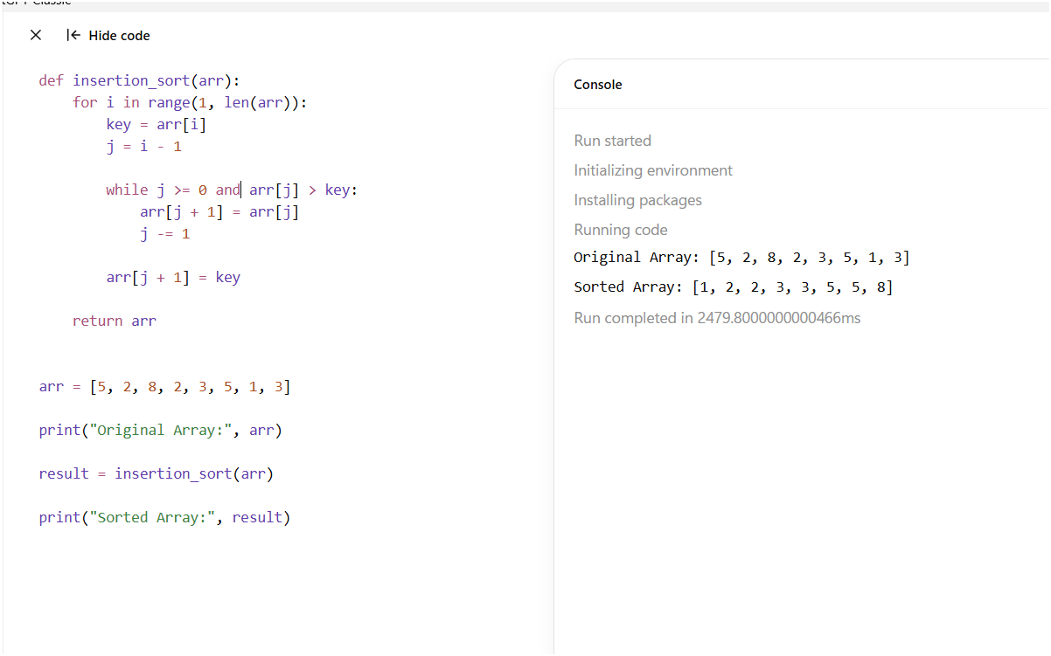
Result
The Insertion Sort algorithm was successfully implemented to sort an array containing duplicate elements in ascending order.

